Q1.
Answer is B.

A: In Oracle, subtracting two DATE values returns the difference in days as a number.This works to calculate days until maintenance, but it includes past maintenance dates, which will appear as negative numbers.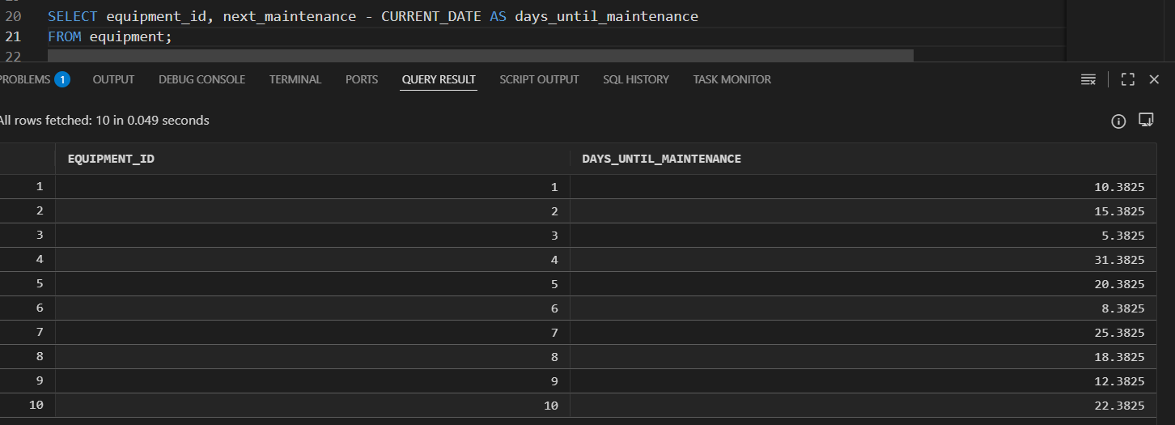

B: Calculates the number of days until the next scheduled maintenance.
Filters out past maintenance dates to avoid negative values.
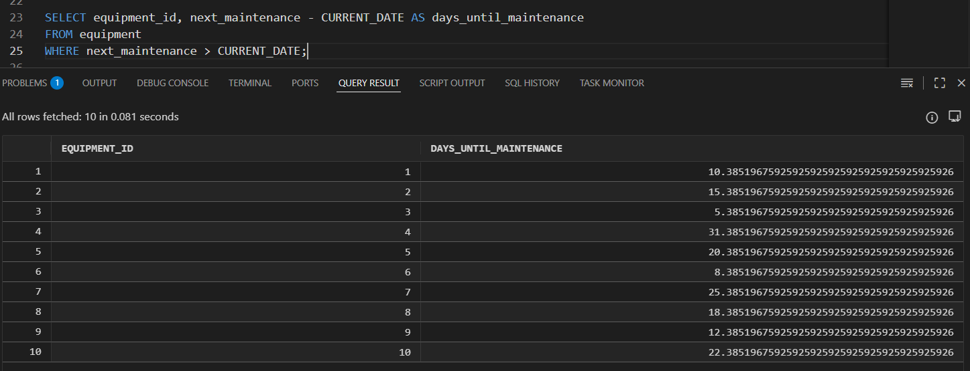

C: Work but Incorrect.
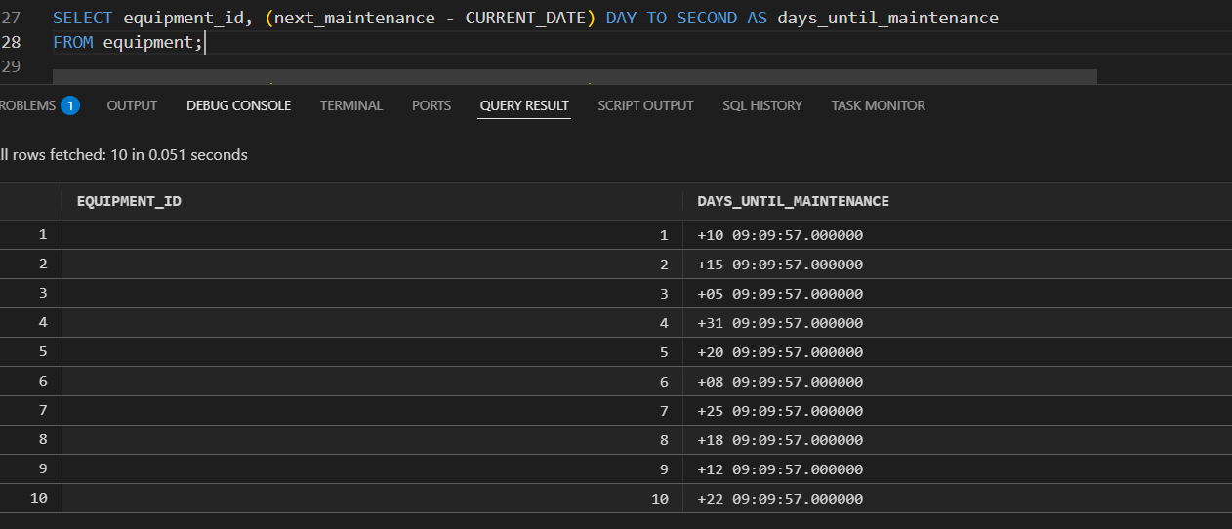
D: Incorrect. DAY cannot be applied to a numeric difference.
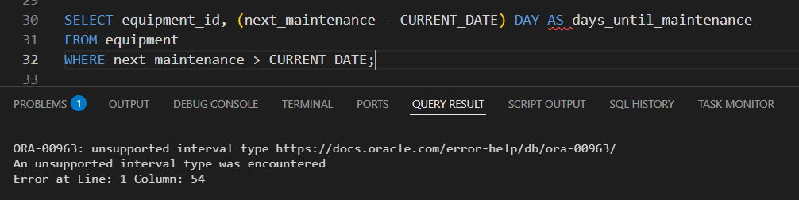

Q2.
Answer is A.

A: Correct. calculates the date exactly 66 months ago.
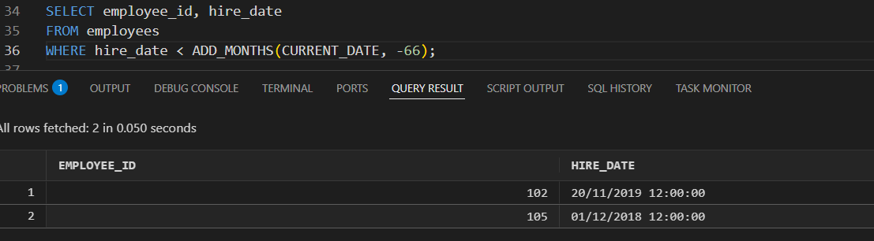

B: Incorrect. Invalid syntax.
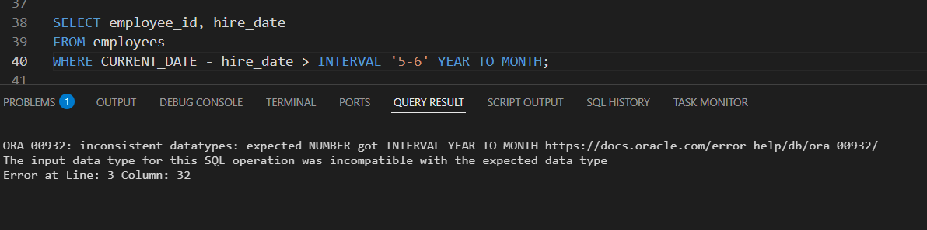

C: Also Correct.returns the total months between two dates.
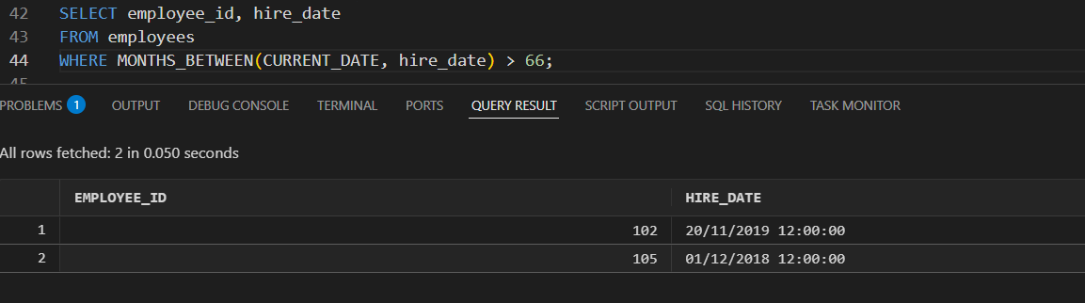

D: Correct but not simple.
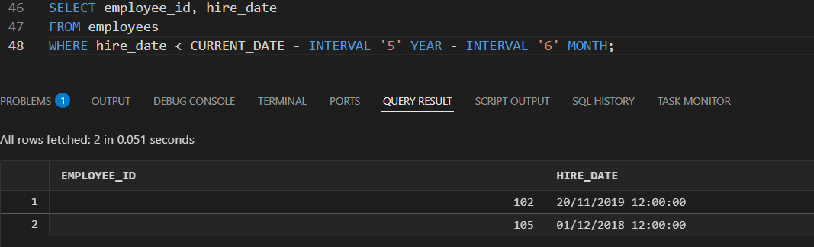

Q3.
Answer is A.

A: Valid and correct. Includes session time zone.
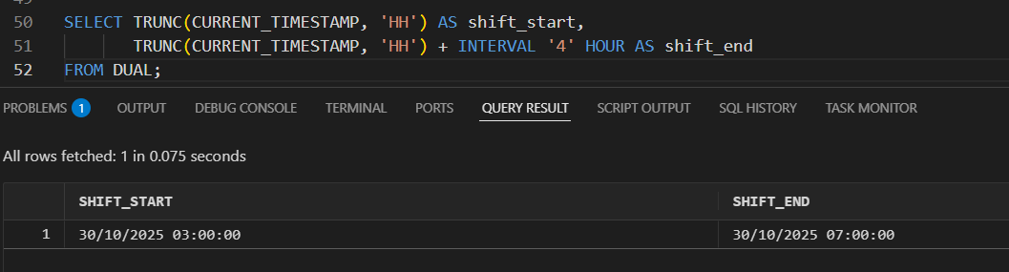

B: Also valid and correct.Local time zone.
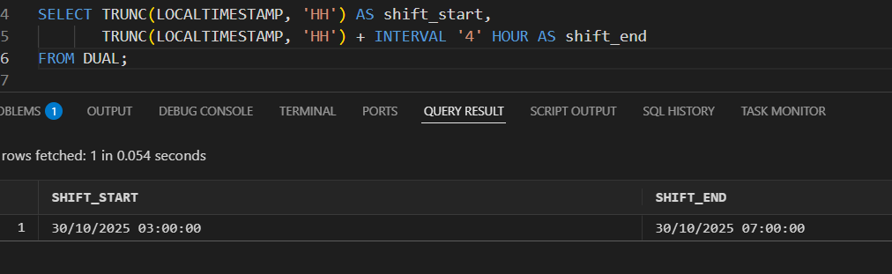

C: Incorrect for “start of the current hour” requirement.

D: Also correct.server time zone.
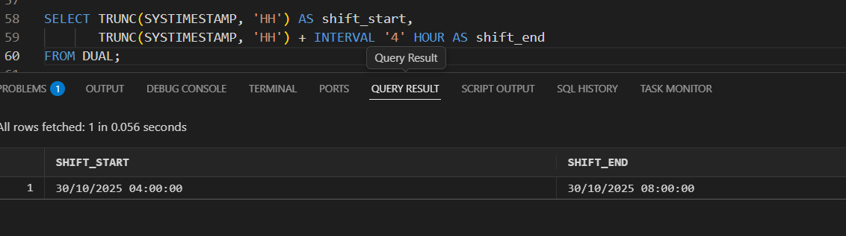

Q4.
Answer is A.

A: Correct. Simple, adds 14 days each iteration.

B: Also correct, more explicit about interval type.

C: Incorrect. Invalid in Oracle.

D: Incorrect. Oracle does not support WEEK in INTERVAL.

Q5.
Answer is C.

A: Incorrect. Rough approximation, ignores partial weeks
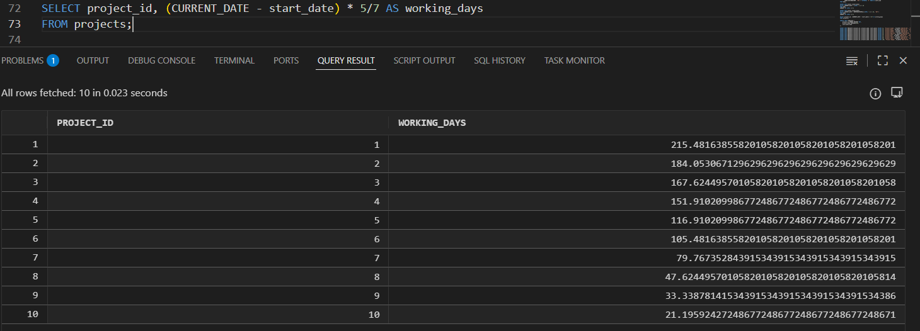

B: Correct. Accurate, integer working days
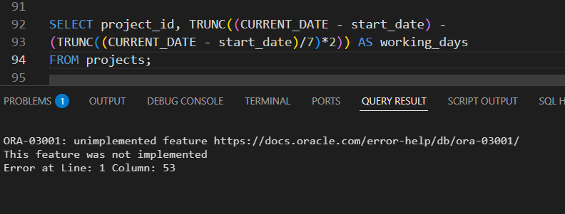

C: Correct.
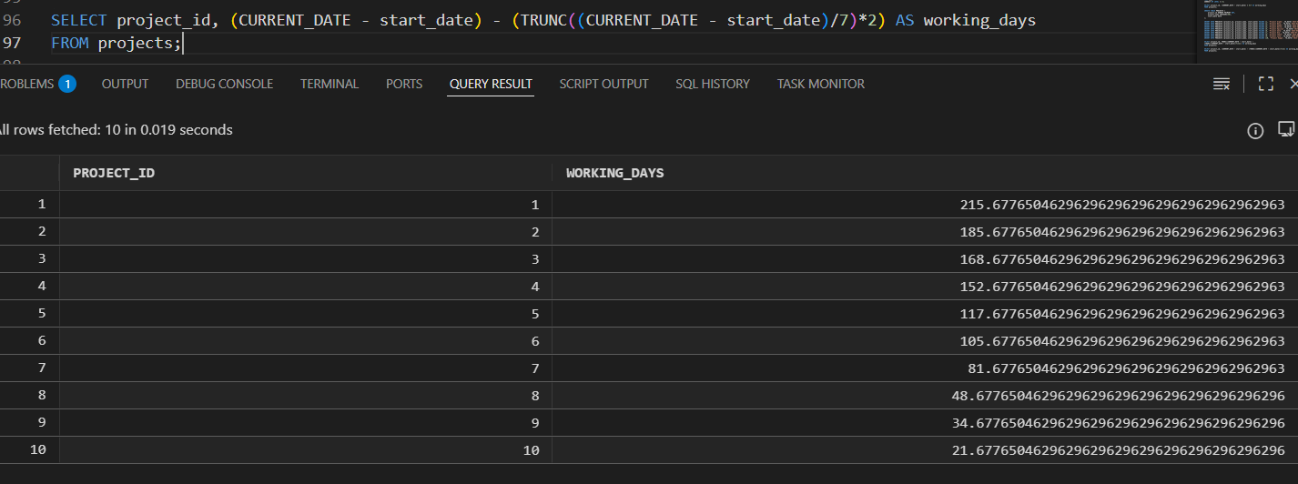

D: Also correct.
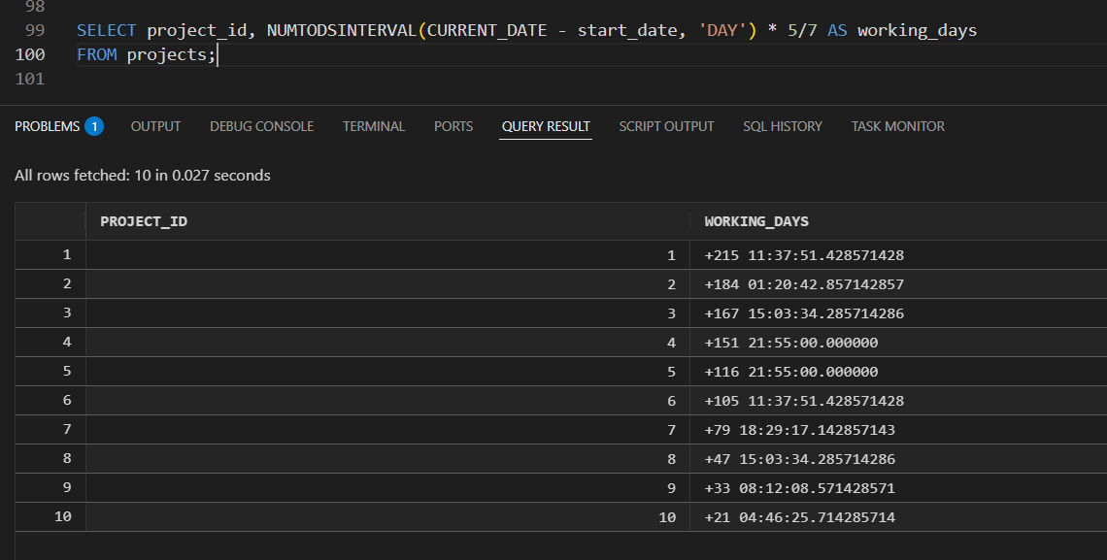

Q6.
Answer is

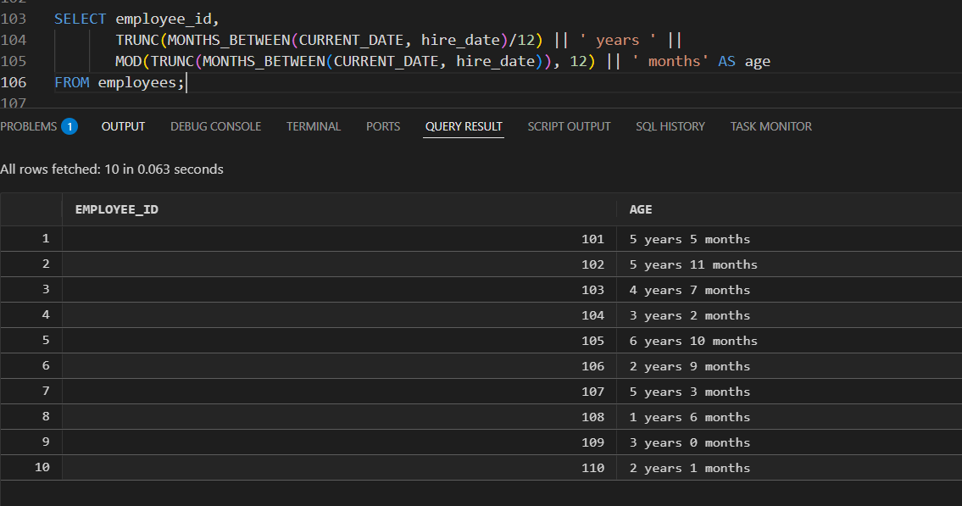

A: Incorrect. Invalid, cannot extract YEAR/MONTH from number of days

B: Correct. Accurate, correct years and months.

C: You can’t convert a date subtraction directly into a YEAR TO MONTH interval like this.

D: Not accurate for real date calculations.

Q7.
Answer is A.

A: Clean & standard; best practice.

B: Works fine, slightly longer.

C: Good for numeric duration input.

D: Invalid syntax for Oracle.

Q8.
Answer is A.

A: Correct and clean.

B: Syntax valid, same result as Option A

C: Also correct.

D: Also correct.

